Workshop from devices to datasets

Welcome to this workshop where we let you test real-time data recording with a research device and where you can process your own or a provided dataset to understand how data filtering and signal artifacts can impact fiducial detection and model feature calculation.

We will work in smaller groups, where each group will have the time to experiment with data recording.
Processing with example and/or recorded data
Data-recording with calamari

Please note that all participation is voluntary. We provide you with a sample dataset of two individuals who perform interventions such as rest, paced breathing (6bpm) and handgrip. You can also use your own dataset; with interventions you choose to do. Only perform interventions that are comfortable for you, and which are allowed by the researchers.

If you choose to process your personal data, please note:
- The measured data is personal data and may contain health related information. For example, arrythmias can be detected.
- The data may contain artefacts, which might occur as pathophysiological data.

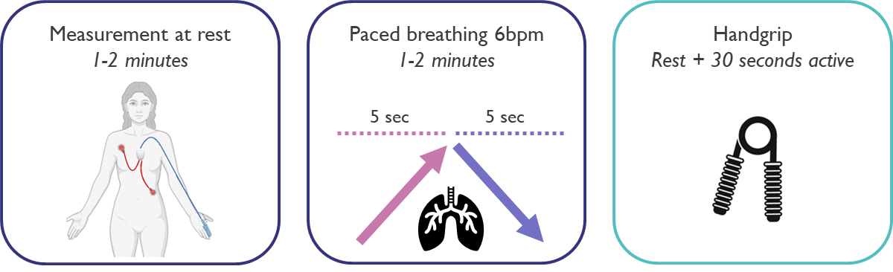
Figure 1 Interventions in example datasets

The exercises will start on the next page.
Exercises:

- Create hypotheses
The clinical use-case of this workshop will be blood pressure. At the end of the exercises, we will explore the relationship of heart rate, pulse arrival time and pulse pressure with blood pressure or exercise. To do so, we ask you to write down your hypotheses:

If I perform a hand grip test, I expect my
Heart rate to:
&
Blood pressure to:
If I do paced breathing, I expect my:
Heart rate to:
&
Blood pressure to:
If my blood pressure increases, I expect my pulse wave velocity to:
If my blood pressure increases, I expect my pulse pressure to:

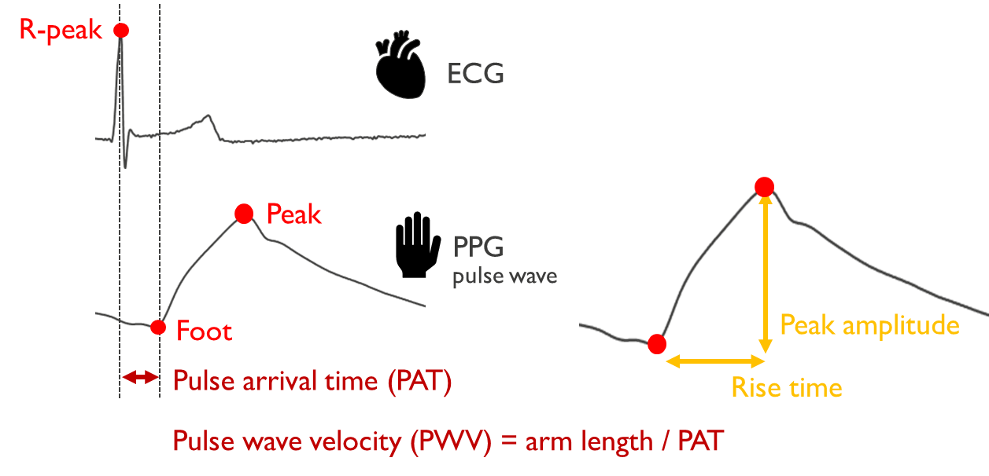
Figure 2 Explanation of the fiducials (R-peak, peak, foot) and features (PAT, PWV, peak amplitude)

- Upload your data
We will start by uploading the dataset. Add your folder directory and the performed interventions in section 1.

If this works correctly the name of the selected recording will be printed.

Proceed to section 3 to plot the data. Green lines will mark the start of interventions and red lines the end of an intervention.

Can you see your interventions back in the signal? Do you see different patterns in the signals for the different activities? Are these patterns within your expectation?

- A closer look at the signals
We have made the processing a little bit easier today. Like controlled studies, we were able during data collection to select time markers. This annotation allows us to find specific periods of time where an intervention is performed. We will use these segments to explore the effect of the interventions on the signals and to see how data quality assessment can impact the outcome.

In section 4 you can select a data segment where an intervention is performed. Select “rest” first and print the output. Second, select an intervention that you think is interesting and print the output. Do you see a difference in signal behavior and noise level? In which signals can you see breathing patterns?

- Test your data cleaning on a set of resting data
We will further zoom in on a segment of data and see how data cleaning affects the fiducial detection. Fiducials are markers in the signal that can describe the pulse morphology. Here we will focus on three basic markers: the ECG R-peak and the PPG peak and foot. See the example below on how this should look like.

Rerun section 4 while selecting ‘rest’ as intervention. Continue to section 5 and start with running this section as it is. In the section you can turn ON and OFF some filters. Try this and see what happens. Are you known to signal filtering? Try out additional filters if you like!

If you want to zoom in on a specific section, you can find the limit selection below the filtering in the code. Don’t forget to check the parts of the signal where you expect noise.

Optional: If you want to see the effect of the filtering, you can write an additional plotting function to plot these signals.

Repeat the above steps for paced breathing or handgrip. Happy with the filtering? Continue to the next exercise.

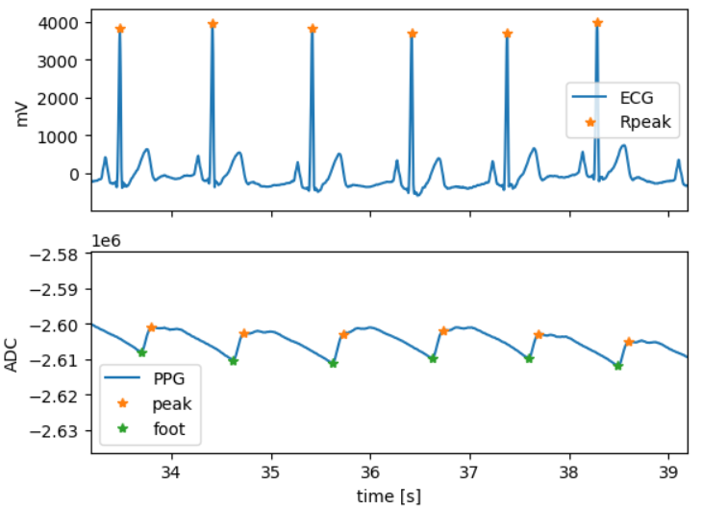
Figure 3 Example of successful fiducial detection

- Post-processing and feature calculation
In section 6 the features heart rate (HR), pulse arrival time (PAT), pulse wave velocity (PWV) and peak amplitude (PA) are calculated.

First, complete the calculation of the pulse amplitude, for an explanation of the features see figure 2 in exercise 1. After completion, run this section for a paced breathing or hand grip activity, to see what the output is.

# Bonus: PAT can be calculated using foot or peak, this is available in the code. Do you see different results? Which of the two looks more robust?

Check for yourself:
- How does heart rate respond to this activity?
- Does this match with your hypotheses?
- Do you see patterns in the other features?
- Do you see outliers in the features? If so: check the signal using section 5.

- Feature optimization and model impact
In the exercise above you have looked at the calculation of features from the signal. While doing the calculation, you might have noted outliers.

Signal filtering can reduce outliers, but this is not always sufficient and, in that case, post-processing is needed. Choose an intervention where you see outliers and perform post-processing, you can think of using physiological information or using a more mathematical approach. Draft code for post-processing the heart rate is given in the notebook in section 7.

If you are happy with your post-processing, you can further check your hypotheses by running the BP model in section 7.

The model uses pulse wave velocity to estimate blood pressure. We also expect blood pressure to correlate to the peak amplitude. Make a scatter plot with the two values, what do you see? Is the relationship positive or negative? Hint: test this for the intervention where you expect the largest change in blood pressure.

